What is SEO:
Search engine optimization (SEO) is the process of improving the quality and quantity of website traffic to a website or a web page from search engines. SEO targets unpaid search traffic (usually referred to as "organic" results) rather than direct traffic, referral traffic, social media traffic, or paid traffic.
Organic search engine traffic originates from a variety of searches, including image search, video search, academic search,^{[4]} news search, industry-specific vertical search engines, and large language models.
As an Internet marketing strategy, SEO involves understanding how search engines operate, the algorithms that shape their results, the information users seek, the keywords and queries they enter, and the specific search engines favored by the intended audience. SEO helps websites attract more visitors from a search engine and rank higher within a search engine results page (SERP), aiming to either convert the visitors or build brand awareness.^{[5]}
How SEO Works:
- Crawling: Search engines use automated bots (crawlers) to scan websites and discover new or updated content.
- Indexing: After crawling, the content is analyzed and stored in the search engine's index, a massive database of web content.
- Ranking: Search engines rank indexed pages based on relevance, quality, and user experience, determining which pages appear higher in search results.
Importance of SEO
SEO is crucial for businesses and website owners because it helps them reach their target audience effectively. Key benefits include:
- Increased Visibility: Higher rankings in search results lead to more visibility and traffic.
- Cost-Effective Marketing: Unlike paid advertising, organic traffic from SEO is sustainable and can grow over time with ongoing optimization efforts.
- Improved User Experience: SEO practices often enhance the overall user experience on a website, making it easier for visitors to find what they need.
Reference:(What Is SEO Marketing ? Definition, Importance, Types and Benefits - GeeksforGeeks)

What is GEO:
GEO focuses on creating content that AI answer engines consider authoritative and relevant. Unlike traditional SEO, which targets ranking on search engine result pages, GEO ensures your content is included in AI-generated responses. This means:
- Your content reaches users via AI assistants.
- You gain visibility in emerging AI-driven search ecosystems.
- You stay ahead of competitors who only focus on traditional SEO.
How it works:
The key to successfully implementing GEO is understanding the processes of generative AI and leveraging this knowledge to create content that resonates with both humans and machines. Over the last few months, more and more data has started to come to light showcasing how this type of work can be executed with excellence and how it can translate into real outcomes for a business. Here are some data backed strategies that we have seen first hand and found through data analysis to effectively influence the way a brand shows up in the LLMs. These are techniques that brands can incorporate in their content strategy today to generate LLM oriented results for months to come: (Source: https://foundationinc.co/lab/generative-engine-optimization)
GEO vs SEO
For so long, SEO has helped businesses climb Google rankings in the fight to page one. It has also driven traffic to websites and helped to convert clicks into customers for countless brands. But, as generative AI redefines the way we use search, we must adapt.
SEO is all about making your content visible to search engines like Google or Bing. These search engines trawl pages based on a series of signals like keywords, backlinks, metadata, mobile performance and user engagement. On the other hand, GEO focuses on generative engines. GEO is all about making your content understandable, trustworthy and retrievable by generative search engines that consolidate answers instead of listing links to other websites.

GEO understands how AI-driven platforms prioritise and display your content through tracking referral traffic from AI engines and cited sources. The question is no longer ‘can I rank first for that?’ but rather ‘can my content be used in the AI’s answer?’. So, you need to start thinking about creating content that's well-structured, factual and context-rich. It needs to be the kind of material that an AI model can easily quote or reference to support its answers.
It’s important to remember that SEO and GEO aren’t competing against each other, but are actually working in tandem to work for your digital strategy. SEO ensures your site is technically discoverable, but GEO ensures your site is discoverable by AI systems specifically. Together, they work towards the future of search, serving all algorithms and working to provide as much visibility as possible. 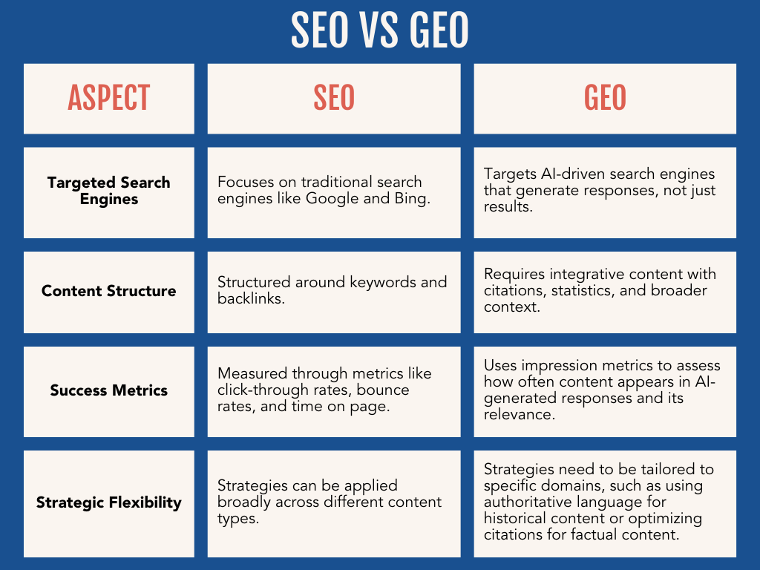
Reference: What’s Generative Engine Optimization (GEO) & How To Do It,
What is GEO (Generative Engine Optimisation) and Why Does it Matter? | Motive PR

What is AEO:
Answer engine optimization (AEO) improves a brand’s visibility in AI-powered answer engines like ChatGPT, Perplexity AI, and Microsoft Copilot. Common optimizations for earning mentions and citations in these engines include content creation, schema markup, and backlinks.
What is the difference between AEO and SEO?
There are a few differences between AEO and search engine optimization (SEO), including:
Area | AEO | SEO
Platform | Answer engines, like ChatGPT, Perplexity AI, and Microsoft Copilot | Search engines, like Google, Bing, and DuckDuckGo
User targeting | Conversational questions, like “what are some good restaurants in Iceland?” | Keywords, ranging from a few to several words, like “best restaurants in iceland”
Metrics | - Mentions  - Citations  - Placements  - Referral traffic  - Conversions | - Domain authority  - Rankings  - Impressions  - Traffic  - Conversions

Why is answer engine optimization important?
Answer engine optimization is important because search is changing. From AI platforms to AI assistants, users have options when it comes to researching problems, discovering brands, and purchasing products.
This shift emphasizes the need for search everywhere optimization, ensuring that content is accessible and relevant across various platforms.
- 400+ million people use OpenAI products each week (Source)
- 4x is how much downloads for Bing’s mobile app grew after integrating AI (Source)
- 45% of Millennials use social media for search (Source)
- 25% of organic traffic will shift to AI chatbots and other virtual agents by 2026 (Source)
Answer-focused sites like Stack Overflow have seen this change in user behavior first-hand. Following ChatGPT’s launch, the site’s visits decreased by 14% in March 2023 and then by 18% in April 2023.
Even though companies are seeing declines in organic traffic, their revenues are growing.
NerdWallet, for example, grew its revenue more than 35% in 2024 while monthly website traffic decreased by 20%. This trend in revenue up and traffic down emphasizes that users aren’t shopping less — they’re shopping differently.
What makes AEO challenging?
1. Tracking performance
2. Getting internal support
3. Optimizing for answer engines
Reference: What Is Answer Engine Optimization? The SEO's Guide to AEO
How SEO, GEO, AEO connected?
- SEO is the base layer: without solid technical SEO, content, and authority (links, E-E-A-T), AEO and GEO usually fail because search and AI systems won’t reliably find or trust your site.
- AEO is the answer layer on top of SEO: it uses schema, FAQs, and clear answer blocks to turn SEO content into “answer-ready” material for snippets, AI Overviews, and voice search.
- GEO is the AI reasoning layer: it connects and contextualizes your content so generative engines reuse it in chains of reasoning, not just as one-off quotes.
A useful way some practitioners describe it: SEO helps you show up, AEO helps you stand out as the answer, GEO helps you get quoted by AI.
Roles in one strategy
- In practice, modern “Search Everywhere Optimization” uses all three together so your brand appears in:
  - Classic organic rankings (SEO)
  - Featured snippets, AI Overviews, voice replies (AEO)
  - AI chat and generative answers with citations (GEO).
- Most frameworks now treat AEO and GEO as specialized extensions or subsets of SEO, not replacements, because they still depend on the same core signals: relevance, structure, and authority.
Aspect | SEO | AEO | GEO
Main goal | Rank in organic search results. | Get chosen as the direct answer in snippets, AI Overviews, and voice. | Get cited and reused by generative AI systems in their responses.
Focus | Visibility in SERPs. | Clarity and answer formatting. | Context, consistency, and machine understanding
Typical tactics | Technical SEO, keyword research, content depth, link building. | FAQs, concise answer blocks, schema, intent-matched content. | Entity mapping, robust documentation, interlinked topics, monitoring AI citations.
Key metrics | Rankings, organic traffic, CTR, conversions. | Featured snippets, AI Overview presence, voice answer share. | AI citation frequency, brand mentions in AI, conversions from AI-referred traffic.

Need of SEO, GEO, AEO:
Why SEO is still non-negotiable
- SEO brings consistent, high-intent organic traffic without paying for every click, which compounds over time and is far cheaper than ads in the long run.
- Strong SEO builds trust and authority (if you rank, people assume you’re credible) and supports all your other channels like ads, email, and social.
- Good SEO forces you to have a fast, usable, technically sound site, which directly improves conversions and user experience.
Why AEO (Answer Engine Optimization) matters
- AEO helps you win the single answer spots: featured snippets, “position zero,” AI Overviews, and voice replies, instead of being just one blue link among many.
- It increases visibility and click-through rates because users often choose the result that clearly answers their exact question.
- AEO-style content (clear Q&A, structured data) improves user experience and tends to attract more qualified traffic that converts better.
Why GEO (Generative Engine Optimization) is emerging
- GEO makes your content show up and be cited in AI tools and generative search (ChatGPT, Perplexity, Copilot, etc.), which are becoming a major discovery channel.
- It lets you influence how AI systems talk about your brand, affecting visibility, sentiment, and reputation in AI-generated answers.l
- Because few brands are doing GEO well yet, early adopters can capture an advantage in an AI-dominated search landscape.
Simple way to think about it
- SEO: helps people find you in search results.
- AEO: helps you be the answer when the user wants a quick, direct response.
- GEO: helps AI tools quote and represent you correctly inside their generated answers.

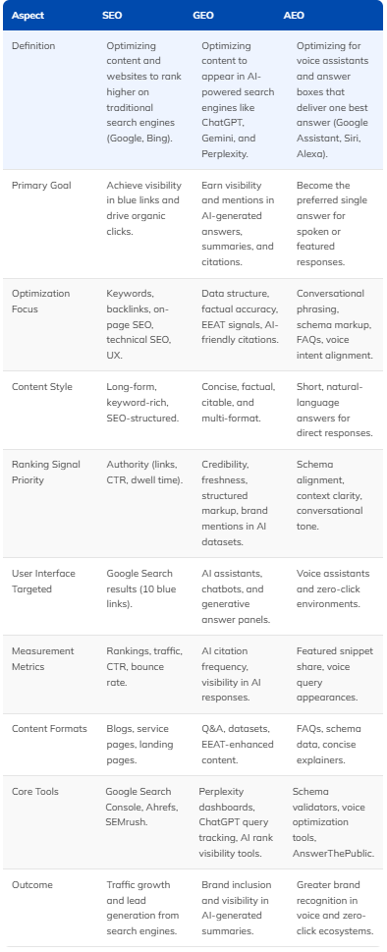
Difference:

How ChatGPT is going to launch AEO:
ChatGPT is undergoing significant changes, particularly in Answer Engine Optimization (AEO), which focuses on how content is optimized to appear in AI responses. Here are some key points:
- AEO Strategy: Brands are encouraged to build topical authority around their niches to show up in ChatGPT responses, enhancing organic traffic and credibility.
- Ad Testing: OpenAI is testing ads in ChatGPT, with ads appearing at the bottom of responses and being context-aware. The ads will run on both the Free tier and the new ChatGPT Go subscription level.
- Privacy and Ad Influence: OpenAI has stated that ads will not influence the answers ChatGPT provides, and user conversations remain private from advertisers.
- Future of AEO: As AI search engines become more prevalent, optimizing content for AEO is crucial for brands to maintain visibility and attract AI-driven traffic.
These developments indicate a shift in how brands interact with ChatGPT and the importance of AEO in the AI landscape.

How Facebook Started Marketing Content
Facebook's marketing content began with simple "Flyers" in 2004, which were text-based messages that advertisers could target to students based on their school. These initial ads proved to be a hit with businesses, providing early revenue and demonstratingdemand for targeted advertising. The platform's growth and the success of these ads led to the launch of Facebook Pages and the official Facebook Ads platform in 2007, allowing businesses to create dedicated pages and use targeted advertising to reach specific user demographics and interests. This evolution marked a significant milestone in Facebook's journey towards monetization and advertising, setting the stage for its rapid growth and dominance in the social media landscape.

How google started SEO:
Google, founded in 1998 by Larry Page and Sergey Brin, was based on their research paper published at Stanford University titled “The Anatomy of a Large-Scale Hypertextual Web Search Engine”. In this paper, they outlined their concept for a new way of ranking website pages in a search engine, called PageRank. This research paper formed the conceptual basis for the Google algorithm today, even with the many changes over the years.
Since the time Google became publicly accessible, webmasters have been trying to manipulate Google search listings to get their websites to rank at the top. This practice came to be known as Search Engine Optimization, or SEO for short.
As the Google algorithm has changed, practices for SEO have developed and changed. These practices may fall into whitehat or blackhat categories, measured based on their purpose to either work with or manipulate the PageRank system. In this blog, we will identify the four primary stages in the history of SEO and explain how the algorithm has evolved over that time.

SEO Era | Timeline | Characterized By
Links & Keywords | 1998 – 2006 | Keyword stuffing, link buying, and paid guest posts
Content Marketing | 2007 – 2014 | 500-word articles with a stock image at the top
Hub & Spoke | 2015 – 2022 | Long, thorough pages that link to a cluster of related content
Content Quality | 2023 – Today | Focus on fulfilling search intent, original data, and unique organization
Reference: The History of SEO: A Primer - Focus Digital

How LLMredi is starting?
LLMredi is starting as an “AI-readiness” audit and optimization platform that helps websites become more visible and understandable to LLMs like ChatGPT and Gemini, i.e., LLM optimization plus GEO/AEO style checks.
What LLMredi is trying to solve
- Their core thesis is that traditional SEO is not enough and sites now need to be “AI-ready” so that LLMs can crawl, interpret, and reuse their content in answers.
- They position this as making content “visible to AI” and “rewriting web visibility for the AI era,” very much aligned with LLM optimization + GEO/AEO thinking.
How they are starting (product side)
- LLMredi has launched an online audit where you enter a URL and get a multi-metric report on how AI-friendly your site is (crawlability, structure, entities, etc.).
- The platform tests content across major AI models and gives step-by-step recommendations plus an AI-native scoring system to track improvements over time.
How they are starting (company side)
- The team describes themselves as product builders from India and the US who discovered the “AI visibility” problem while building a site, then turned it into LLMredi.
- They’ve launched an early free beta (including on Product Hunt) targeting website owners, SEOs, agencies, and marketers who want to understand how AI sees their sites.
Where this fits with SEO / GEO / AEO
- In the broader landscape, LLMredi is part of a new wave of tools focused on LLM optimization and GEO/AEO (similar to platforms like LLMrefs and other AI visibility trackers).
- Practically, that means their audits are an extra layer on top of classic SEO, aimed at improving how often and how well AI systems can reference your site in generated answers.
Analsis of business model
TL;DR: SEO is focused on ranking (first) in search engine results. AEO structures content to be surfaced as direct, spoken, or written answers in AI Overviews and voice assistants. GEO ensures content can be understood, cited, and incorporated into responses of generative
References: AEO Vs. GEO: What Small Businesses Need To Know

Aspect | SEO | AEO | GEO
Main revenue type | Retainers + projects + SEO tools.primaryposition+3 | Retainers add-on + answer tools.growth+3 | Premium retainers + AI visibility tools.growth+5
Maturity | Very mature, price pressure, lots of competition.primaryposition+2 | Emerging, often bundled into SEO.growth+4 | New, high-margin, less crowded.srpro+4
Core promise | More organic traffic and leads.primaryposition+3 | More direct answer placements and better CTR.growth+3 | More AI citations and controlled brand narrative in AI.srpro+4
Typical buyer | Marketing heads, founders, ecommerce, local businesses. | Same buyers, plus product/content teams.growth+3 | Larger SaaS, enterprises, brands sensitive to reputation.

Perplexity link for simple explanation: https://www.perplexity.ai/search/how-seo-geo-and-aeo-are-connec-UlXJFL2rRaCYPXdG0gitxQ#5

